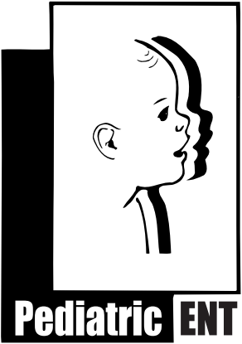
Bruce R. Maddern M.D., P.A.
Post Frenuloplasty (procedure to resolve “tongue-tie”) Instructions
Ankyloglossia (“tongue-tie”) is a condition present from birth in which movement of the tongue tip is restricted due to an unusually short and/or thick frenulum. A frenulum is a band of tissue that anchors the tongue to the floor of the mouth behind the teeth. When the frenulum is too short or tight, the tongue tip is unable to move freely. This may result in difficulty with early bottle or breast-feeding or future speech articulation.
The most common reason to perform frenuloplasty in a newborn is difficulty with feeding or latching. It is often possible to perform the procedure in office for infants under 6 months of age with a local anesthetic. The baby can feed immediately following the procedure.
In toddlers it may be necessary to perform a frenuloplasty because of speech articulation issues. If a frenuloplasty is required for this age group the procedure occurs in the operating room under a brief general anesthesia. The entire procedure usually is complete with in 15 minutes. Speech therapy is necessary to ensure improved mobility of the tongue for older children. General risks from frenuloplasty include bleeding, pain, scarring, and infection.
General Information
- The patient may resume normal activity following surgery, including normal feeding schedule (bottle, breast, or soft food).
- The patient may return to daycare the next day.
- Some discomfort or tongue swelling is expected following this procedure. You may treat your child with Tylenol or Ibuprofen.
- For infants the normal movements of the tongue during breast of bottle feeding is adequate stretching
- Ice pops are a good way to numb the area. After the child finishes the ice pop, use the stick to stretch out the area under the tongue at least once a day to prevent scarring.
- Following the procedure, it is normal to see an area under the tongue that may be yellow, white, brown, or gray. This is a part of the normal healing process. Stitches, if placed, will dissolve in 1-2 weeks
- It is normal to have an increase in drooling briefly following the procedure. This will resolve on its own.
- Toddlers and older children who undergo frenuloplasty for speech articulation issues must be enrolled in speech therapy and can resume sessions in 1-2 weeks.
- Please make sure to follow up with our office 2 weeks after the procedure.

These are general recommendations and representations, and may not be appropriate for every individual, patient, or situation. For any questions please consult with your physician. If you have any questions, concerns, or problems, please do not hesitate to call our office at (904)-398-KIDS (5437)
Updated 11/2017
Bruce R. Maddern, M.D., P.A.
A division of Florida Pediatric Associates, LLC
10475 Centurion Parkway N. Ste. 302
Jacksonville, FL 32256 www.entforkids.com
(904) 398-5437

