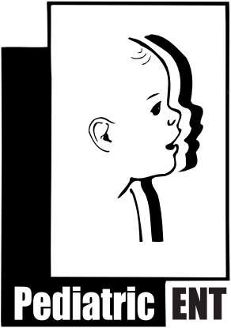
Bruce R. Maddern MD. P.L
Nasal Bleeding/Epistaxis Instructions

Nose bleeds are a common problem in children. They can occur from a variety of medical reasons such as trauma, recent surgery, infection (sinusitis), nasal allergies, nose picking, or over drying. Whatever the cause, it is important to stop the bleeding. You can pursue with your physician the reasons and other evaluations for the bleeding if needed.
Here are few general instructions for managing nosebleeds:
- Try to determine which side is the source of the bleed; right, left, or both.
- Most nasal bleeds in children occur in the front 1/3 of the nose, only ½ to 1 inch inside the rim of the nostril
- You can apply some pressure to the lower nostrils by light compression for a minute or two. Pressure over the bony upper nose or ice pack to the back of the neck are not helpful.
- Do not bend your head backwards as blood can run down the back of your throat. Keep your head elevated. Be calm, sit down, and try to lessen you and your child’s anxiety.
- You can soak half of a cotton ball with Afrin® nasal decongestant spray and place it in the front 1/3 of the nostril that is bleeding completely with home tweezers. Lightly compress the nose with the cotton ball in place for 2-3 minutes, then remove.
- Keep the membranes of the nose moist to help prevent nasal crusting and future nasal bleeding. Apply a glob of antibiotic ointment such as Bacitracin/Polysporin/Neosporin with a Q-tip gently to the front 1/3 of the nose. Coat the inside rim of the nose with the ointment 1-2 times a day
- Other nasal sprays may be discussed such as nasal steroid sprays to lessen bleeding
- Consider using a humidifier in your home or bedroom to keep moisture in the air. Both air conditioning and heating dry out the air we circulate in the home
- If active nasal bleeding can not be stopped despite the measures described above, call our office or your primary care physician. You may need to be evaluated for other causes of bleeding.

These are general recommendations and representations, and may not be appropriate for every individual, patient, or situation. For any questions please consult with your physician. If you have any questions, concerns, or problems, please do not hesitate to call our office at (904)-398-KIDS (5437)
Updated 11/2017
Bruce R. Maddern, M.D., P.A.
A division of Florida Pediatric Associates, LLC
10475 Centurion Parkway N. Ste. 302
Jacksonville, FL 32256 www.entforkids.com
(904) 398-5437

